Supplementary Materials for

Identification of CpG methylation and non-CpG methylation is associated with Lymphocyte specific helicase

Weiwei Lai ^{1,2}, Lianlian Ouyang ^{1,2}, Na Liu ^{1,2}, Shouping Liu ^{1,2}, Ying Shi ^{1,2}, Ling Chen ^{1,2}, Xiang Wang ⁴, Desheng Xiao ¹, Shuang Liu ^{3,*}, Yongguang Tao^{1,2,4*}

- Key Laboratory of Carcinogenesis and Cancer Invasion(Central South University, Ministry of Education), Department of Pathology, Xiangya Hospital, Central South University, Hunan, 410078 China
- NHC Key Laboratory of Carcinogenesis, Cancer Research Institute and School of Basic Medicine, Central South University, Changsha, Hunan, 410078 China
- Department of Oncology, Institute of Medical Sciences, National Clinical Research Center for Geriatric Disorders, Xiangya Hospital, Central South University, Changsha, Hunan, 410008 China
- Department of Thoracic Surgery, Hunan key Laboratory of Tumor Models and Individualized medicine, Second Xiangya Hospital, Central South University, Changsha, 410011 China

* Corresponding author. Y.T. Email: taoyong@csu.edu.cn, Department of Pathology, Xiangya Hospital, Central South University;
S.L. Email: shuangliu2016@csu.edu.cn, Department of Oncology, National Clinical Research Center for Geriatric Disorders Xiangya Hospital, Central South University
This file includes:
Figures. S1 to S3
Supplementary Figures and Figures legends

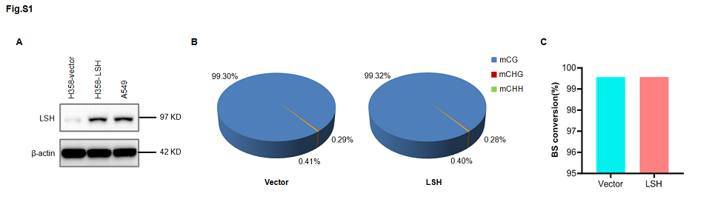Figure S1 Average level of DNA methylation in different patterns and quality control (QC) of bisulfite sequencing.
A. Western blot analysis of exogenous and endogenous LSH protein expression in LUAD cells. B. Average ratio of DNA methylation types in the genomes of vector and LSH. H = A, C or T. The blue, red and green colors represent mCG, mCHG and mCHH, respectively. C. Ratio of RBS conversion in vector (99.558%) and LSH (99.566%) groups.
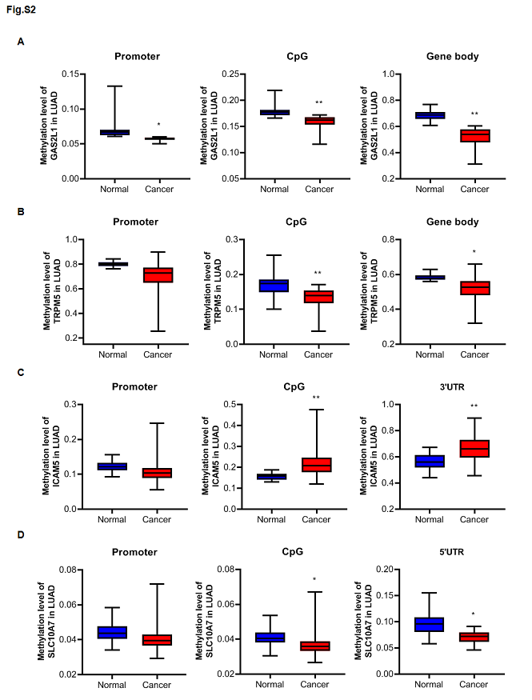Figure S2 MethHC histogram for the methylation level of genes with different regions in LUAD.
A. GAS2L1; B. TRPM5; C. ICAM5; D. SCL10A7. Blue, normal sample; red, cancer sample; *P<0.05; **P<0.005.
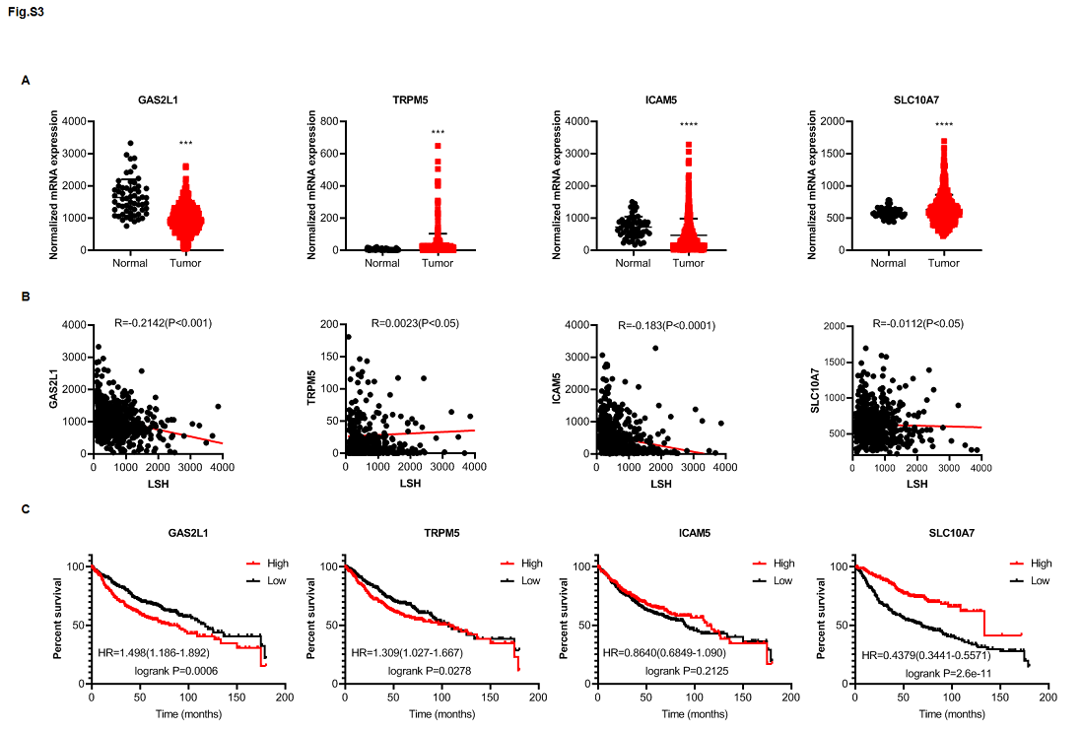Figure S3 The expression and overall survival (OS) rates of indicated genes in LUAD.
A. TCGA analysis of indicated gene expression in 59 normal lung tissue samples and 535 LUAD tissue samples. B. Correlation analysis of LSH and indicated genes. C. Kaplan–Meier curves for the overall survival rates of patients with gene expression levels in LUAD. GAS2L1, TRPM5, ICAM5, SLC10A7.

